**Lab 1 notes:**

**Pre-requisites :**

1. Use Chrome Browser for this lab
2. Plug in the AWS DeepComposer keyboard

**Access AWS DeepComposer console:**

1. Click on Deepcomposer get started page

<https://console.aws.amazon.com/deepcomposer>

2. Enter AWS account ID provided and click Next

3, Enter IAM username and password provided

4. Click Sign In

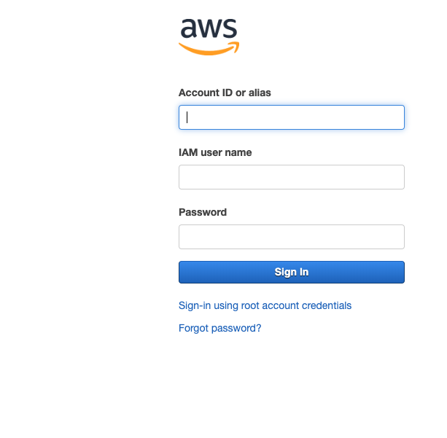

**Get started with composing music:**

1. From AWS DeepComposer getting started page click on “Compose Music” under the “Get started” section on right side of the page.

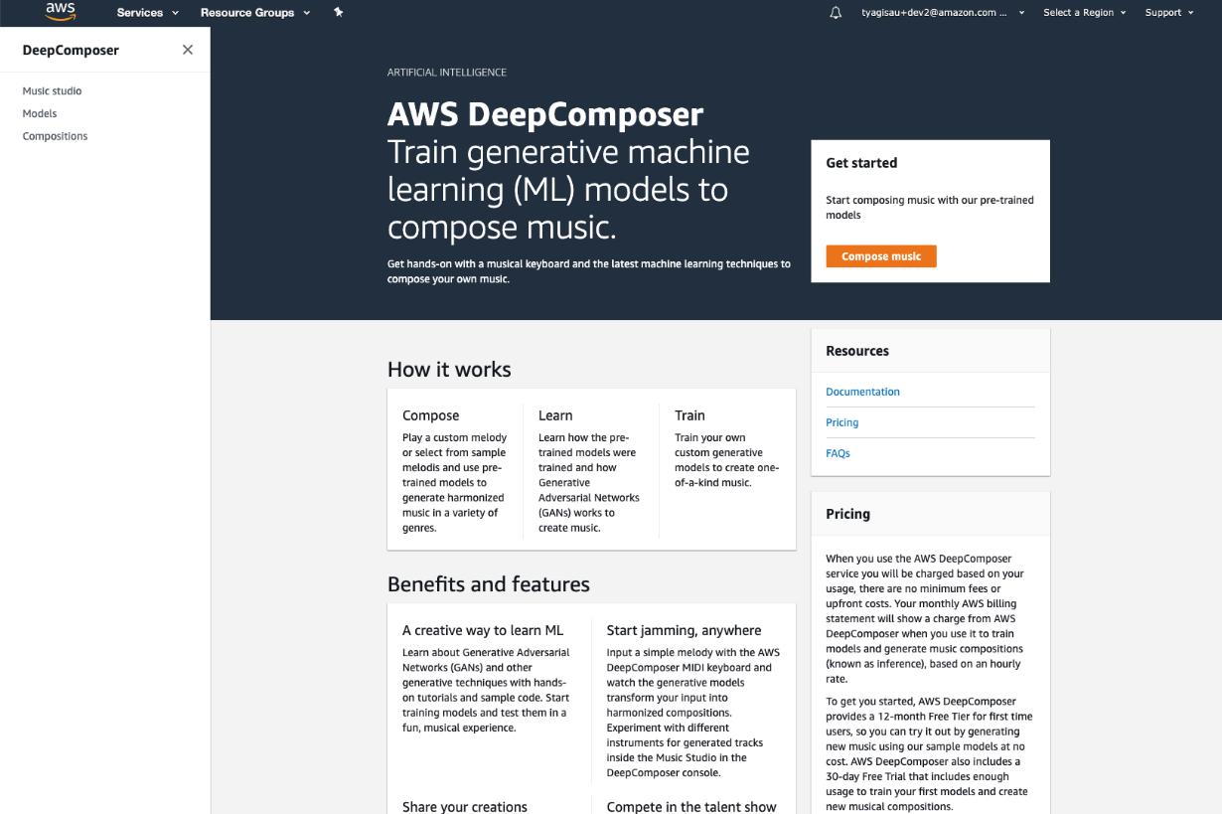

2. **Generate Composition:**

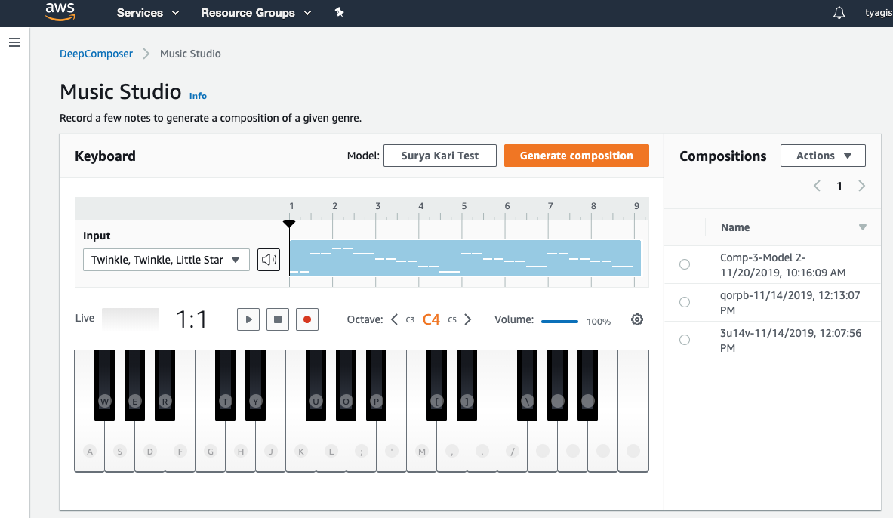

2.1 Choose the play icon  to play the default input melody

2.2 Choose “Generate composition” to generate a composition. AI generated output composition will be created. Choose play icon to play the new AI generated music.

**Next, let’s use your keyboard to create an input melody**

2.3 Click record button  to start recording

2.4 Play the below notes on the physical keyboard provided

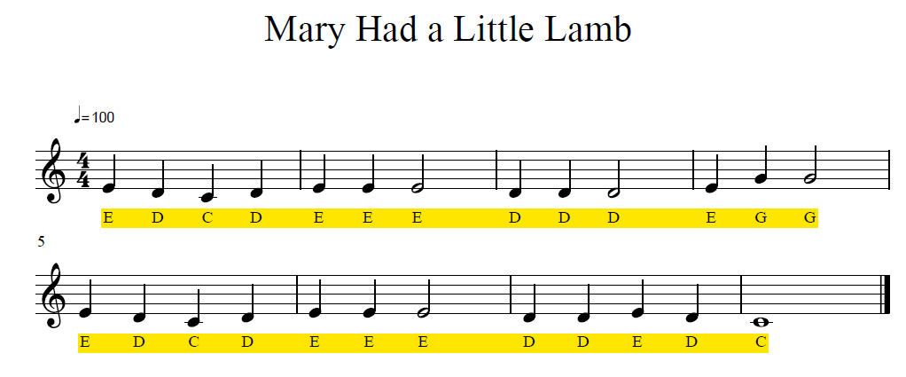

2.5 Stop recording by choosing the record button again

2.6 Play the recorded music to verify the input. In case you don’t like recorded music, you may start recording again by repeating steps 4 to 6 to record music again

2.7 Select model from “Model”: (for example: Jazz)

2.8 Click “Generate Composition” to generate a composition. Note: This step will take few minutes to generate composition from input music file

2.9 Play the composition to enjoy the AI generated music

2.10 Try experimenting with different genres or sample input melody.

Congratulations! You have learnt how to use pre-trained models to generate new music.